**Detailed Information Webpages**

<https://science.nasa.gov/resource/solar-system-sizes/>

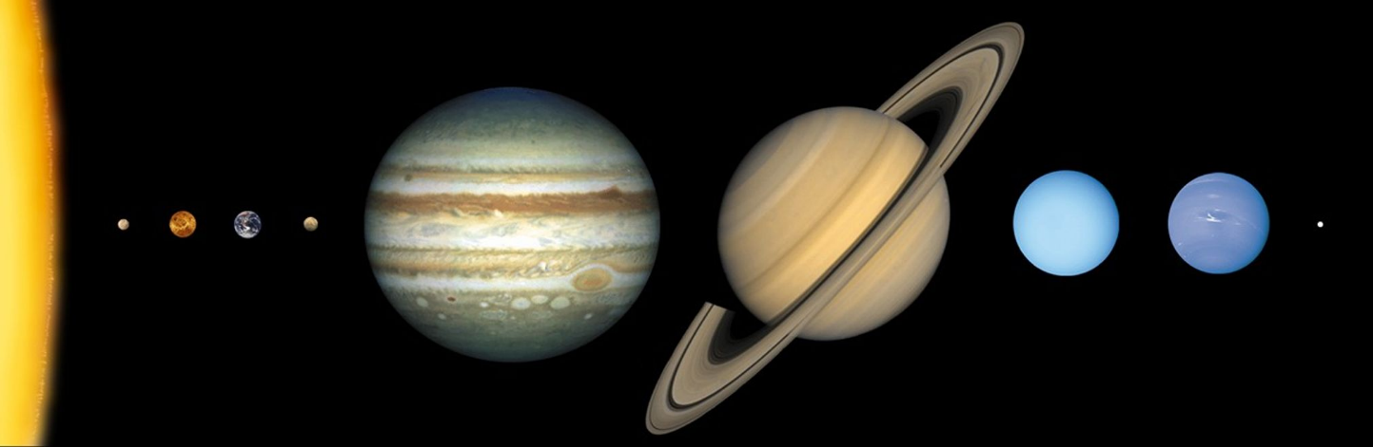

**Suggested standard content:**

Introduction

Orbit / rotation / inclination

Discovery and/or mythology

Composition / temperatures / Atmosphere

Moons / Rings

Exploration

Key Data

**The Sun**

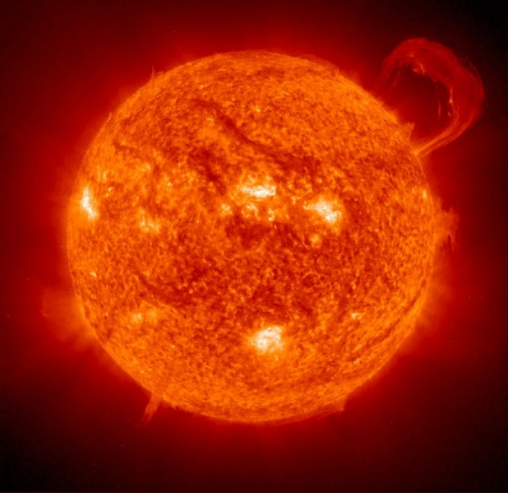**Introduction**

We often take our Sun for granted – it is our constant companion, day in and day out, and we literally would not be able to live without it. At a diameter of nearly 1.4 million kilometres, the Sun is massive compared to the Earth – over 100 times larger in diameter. It contains over 99% of the mass of all of the other objects in our solar system. Our Sun is just an average-sized star. Some stars are hundreds of times the diameter of our Sun, and many are only a tenth the size of our Sun.

**The core**

At its core lies the engine that generates the light *The Sun (Image: NASA)*  
 we see and the heat we feel. The temperatures   
here reach 15 million degrees. At these high temperatures and under the massive pressures at the core, hydrogen nuclei can fuse together to create helium. However, a helium nucleus is slightly  
 lighter than the original hydrogen nuclei, and so a by-product of this fusion is that the Sun converts this tiny little bit of extra mass into energy – heat and light – obeying Einstein’s famous formula, E=mc2. There are so many fusion reactions taking place every second however, that this amounts to a total of about 4 million tonnes of mass converted to energy every second – that’s a lot of energy released every second! This amount of the mass of the Sun that is ‘lost’ every second may seem alarming, but we need not panic – the Sun contains lots of hydrogen fuel and will be with us for at least another 4 billion years.

**The surface**

Although we cannot see into the core of the Sun, we can, with specialist equipment, see the surface of the Sun. Here we see a constantly changing surface – not only do features such as sunspots come and go, but the Sun also rotates. However, as the Sun is not a solid, but instead a ball of gas, different latitudes of the Sun’s surface rotate at different rates, with the mid-latitudes taking about 25 days, whilst nearer the poles it is more like 33 days to complete one rotation. Although the temperatures at the core reach 15 million degrees, the surface is typically ‘only’ about 5,500oC.

**Solar weather**

In addition to the light we see and heat we feel, the Sun can have other effects on us as a result of what is known as solar or space weather. This is as a result of the charged particles that are emitted from the Sun, sometimes in huge bursts, known as coronal mass ejections. If these ejections are pointed in our direction then the Earth can be hit by a wave of charged particles. Fortunately for us, we have a magnetic field to protect us from these, but we can see the dramatic effect that these 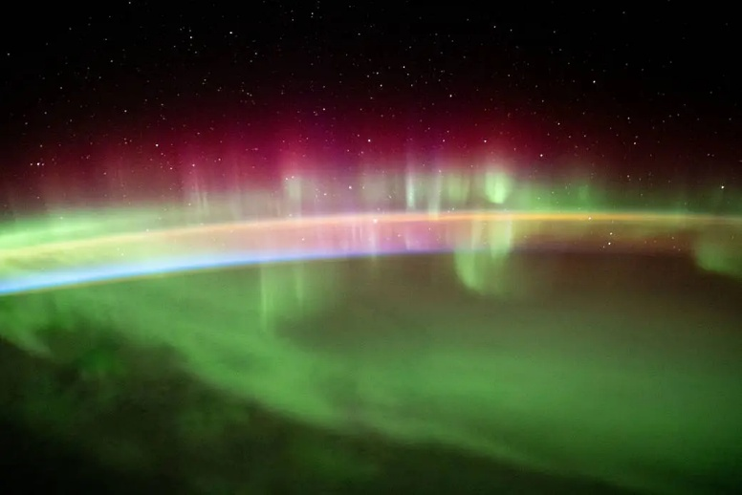have in the form of aurorae – exciting atoms in our upper atmosphere such that they glow red, green or purple. Particularly large events can even knock out our power supply on Earth, as happened in Canada in 1989 when a large geomagnetic storm knocked out the power grid for 9 hours. Fortunately, events of this magnitude do not occur very often, as they have the potential to have very devastating effects. The largest recorded event was in 1859, known as the Carrington event (before the use of large power grids) but it did knock out the  
telegraph networks at the time. *Aurora in the Earth’s atmosphere, as seen from the  
 International Space Station (Image: NASA)*

**Solar Eclipses**

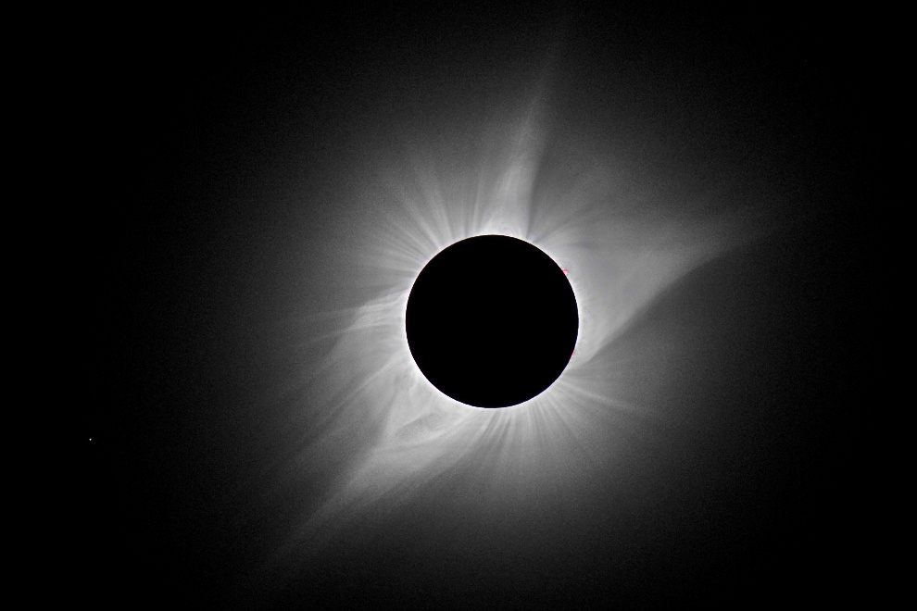One of the most specular ways to view the Sun safely without specialist equipment is during the totality phase of a total solar eclipse. Although there are usually a few total solar eclipses every year, because they are only visible from a very small region of the Earth for each one, then they are a relatively rare event for any given place on Earth. These eclipses are due to a very lucky coincidence that the apparent size of the Moon, as seen from the Earth, is about the same apparent size as the Sun, thereby just covering the disc of the Sun. As the Moon blocks out 100% of the direct   
sunlight of the Sun, it allows us to *Solar eclipse showing the solar corona or outer atmosphere*See the much fainter wispy outer *(Image: Martin Howe, Ewell Astronomical Society)*  
atmosphere of the Sun, known as the   
corona. One of the big puzzles about our Sun is that although the Sun’s surface is about 5,500oC, the corona can reach temperatures of over 2 million degrees! Although the answer to this puzzle remains unsolved, one of the strong contenders to explain this are the strong magnetic field lines of the Sun channelling and concentrating energy from the Sun into the corona.

**Key Data:**

Mass: 330,000 Earth masses

Axial rotation 25 – 33 Earth days

Mean diameter: 1.4 million kilometres (109 Earth diameters)

Core temperature: 15 million degrees

Surface temperature: 5,500oC

Coronal (atmospheric) temperature: >2 million degrees

**Mercury**

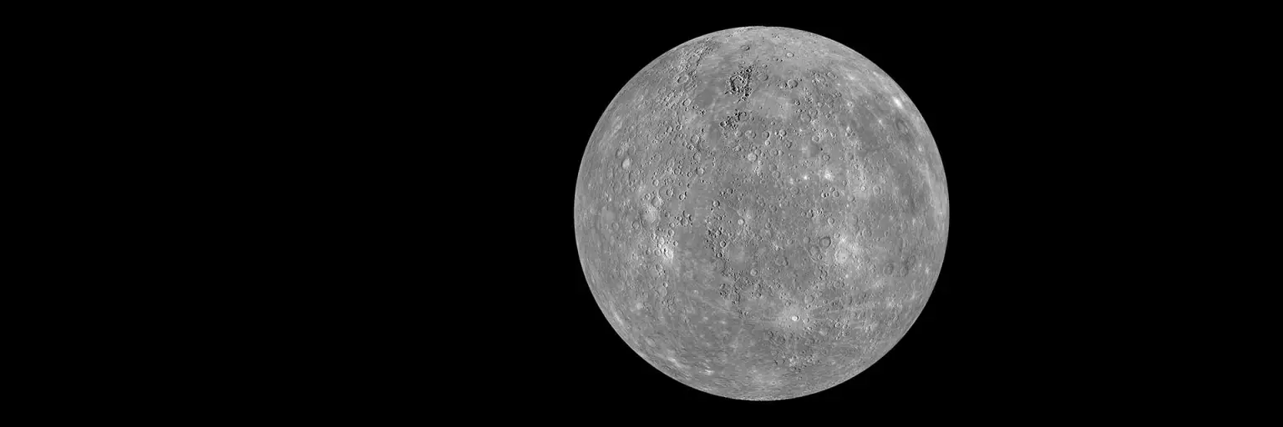**Introduction**

Mercury, with a diameter of a little under 5,000 km, is the smallest of the eight planets, and even smaller than the largest moon in the solar system – Jupiter’s moon Ganymede. It is also the closest planet to the Sun, and the year on Mercury (the time it takes to complete one orbit of the Sun) is just 88 Earth days. Yet one day on Mercury lasts 59 Earth days, which means that there is only 1½ Mercury days in a Mercury year!

Mercury was known to the ancients, and named after the Roman god of commerce. But Mercury was also the fleet-footed messenger of the Roman *Mercury (Image: NASA)*  
gods, and symbolised by a winged hat and   
sandals – appropriate for the fastest planet in the solar system.

**Appearance and** **physical characteristics**

Mercury is known as a terrestrial planet, and is covered in thousands of craters, giving it an appearance similar to our Moon. All of the terrestrial planets would have suffered similar impacts from meteorites, asteroids and comets (and still do). The fact that we can still see the craters implies that the Mercury’s surface is very old and has not experienced much in the way of resurfacing from volcanic lava or erosion from weather. Mercury, like the Earth, is thought to have a dense inner core of liquid iron. Hence Mercury, and similarly Earth, possesses a magnetic field, albeit much weaker than ours. This is quite unusual in that the other terrestrial planets, Venus and Mars, do not have intrinsic magnetic fields. Mercury has essentially no atmosphere – it is too small and too close to the Sun to be bale to retain any significant gaseous envelope. Atmospheres, like Earths, can trap heat from the Sun, so without an atmosphere, temperatures soar during the daytime to 430oC (remember the ‘day’ on Mercury is 59 Earth-days long, for which about half of that time the surface will be directly facing the Sun). Without the protective blanket of an atmosphere, at night time, the temperatures will plummet to –180oC below zero!

**Exploration**

Despite being relatively close to us, it remains one of the least-explored planets by spacecraft. Until recently, the only mission to Mercury was a series of three flybys by the NASA Mariner 10 spacecraft between 1974 and 1975. The next mission was the aptly named NASA MESSENGER spacecraft, launched in 2004.

**Key Data:**

Mass: 0.06 Earth masses

Orbital distance from the Sun: 58 million kilometres

Orbital Period (Mercury year): 88 Earth days

Axial rotation (Mercury day): 58.6 Earth days

Mean diameter: 4,880 kilometres (0.38 of the Earth’s diameter)

Maximum surface temperature: 430oC

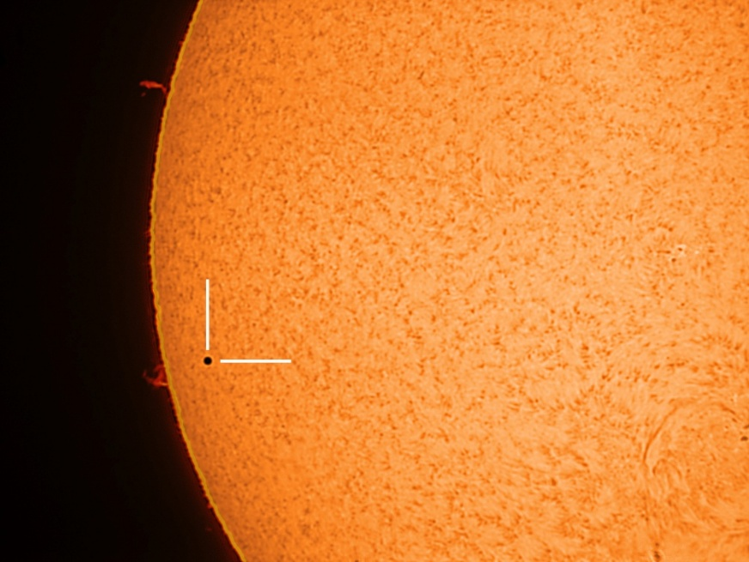

*Mercury is the smallest planet in the solar system – just 0.0035 of the diameter of the Sun, as seen here as a silhouette against the Sun’s surface during a solar transit in 2016 (Image: Martin Howe, Ewell Astronomical Society)*

**Venus**

**Introduction**

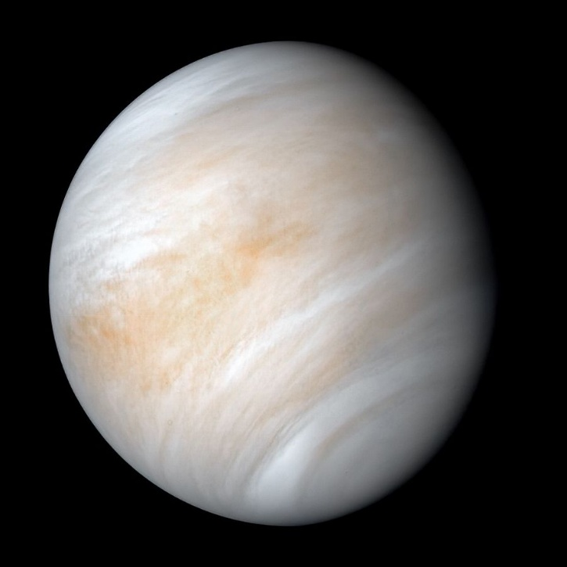Venus is sometimes referred to as “Earth’s twin”, being as it is, the closest planet to Earth and also very similar in size – an equatorial diameter of 12,100 km versus the Earth’s 12,800 km. However, the similarities end there. Venus is cloaked in a thick atmosphere that acts as a blanket, keeping heat locked in, meaning that Venus has the highest surface temperature of all of the planets – even hotter than Mercury! Venus also has a very slow axial spin, meaning a Venusian day is 243 Earth days long – even longer than the Venusian year – the time it takes Venus to complete one orbit of the Sun, which is only 225 Earth days long. Not only that, but Venus is the only planet in our solar system that spins backwards   
relative to the other planets – so the Sun rises in the west and sets in the east.  
 *Venus (Image: NASA)*

Like Mercury, Venus was known to the ancients, and was named after the Roman god of love and beauty – the only planet named after a female god. One can understand why it got this name seeing its outstanding brilliance when seen in the early evening sky, standing out as it does as the brightest object in the sky after the Sun and the Moon.

**Appearance and physical characteristics**

The most obvious visual feature of Venus is its clouds. The dense atmosphere is made principally of carbon dioxide along with clouds made of sulphuric acid, making it a very inhospitable place. Carbon dioxide is a greenhouse gas that has the effect of trapping solar radiation and preventing it from escaping. This means that surface temperatures on Venus can reach 465oC – hot enough to melt lead. This combination of high temperatures and dense atmosphere leads to an extremely high atmospheric pressure at the surface. One bar of pressure is defined as being equivalent to about 1 (Earth) atmospheric pressure at sea level, although by convention, is usually expressed as 1,000 millibars. Venus, by comparison, has an atmospheric pressure at its surface of about 92 bars – the equivalent pressure a diver would feel at nearly 1 km under the ocean! These clouds in the atmosphere are also responsible for making Venus such a bright object in the sky, as they are very effective at reflecting the Sun’s light – reflecting about 70% of the incident light. By comparison, our Moon only reflects about 10% of the light falling on its surface, but only appears so bright to us because it is very close. Although a similar size to the Earth, and also thought to contain and iron core and hot rock mantle, Venus lacks a global magnetic field. Although Venus, like the Earth, has a fluid outer core, Venus rotates so slowly that it is insufficient enough to generate a dynamo effect that results in an internally generated magnetic field such as it does on Earth.

**Exploration**

Our first close-up view of Venus came from the NASA Mariner 2 mission in 1962 – in fact the first ever spacecraft to successfully send back data from onboard instruments of another planet, although there was no camera onboard. The USSR led the way in Venusian exploration with 14 missions launched in the 1960s, although many never made it to Venus. The harsh surface conditions are not conducive to landing spacecraft but there have been a number of successes – all by the Soviet Union, whose perseverance paid off with the first successful landing of a spacecraft on another planet by the Venera 7 probe in 1970. This was followed by a number of other Soviet missions during the 70s with increasing success, including the first (black and white) image from the surface of another planet by the Venera 9 lander in 1975, and colour images from Venera 13 and 14 in 1982. All other missions have consisted of fly-bys, orbiters or atmospheric descent probes, with arguably the most comprehensive and successful mission being NASA’s Magellan mission in the early 1990s which mapped nearly the entire surface using radar, revealing tell-tale signs of volcanism.

**Key Data:**

Mass: 0.8 Earth masses

Orbital distance from the Sun: 108 million kilometres

Orbital Period (Venusian year): 225 Earth days

Axial rotation (Venusian day): 243 Earth days

Mean diameter: 12,100 kilometres (0.95 of the Earth’s diameter)

Maximum surface temperature: 465oC

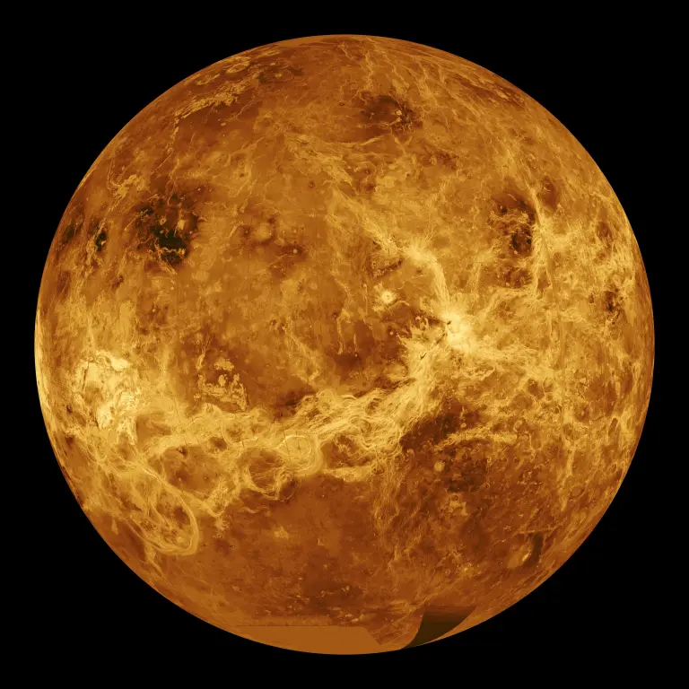

*A radar map of Venus’s surface produce by the Magellan spacecraft showing clear signs of past volcanic activity (Image: NASA)*

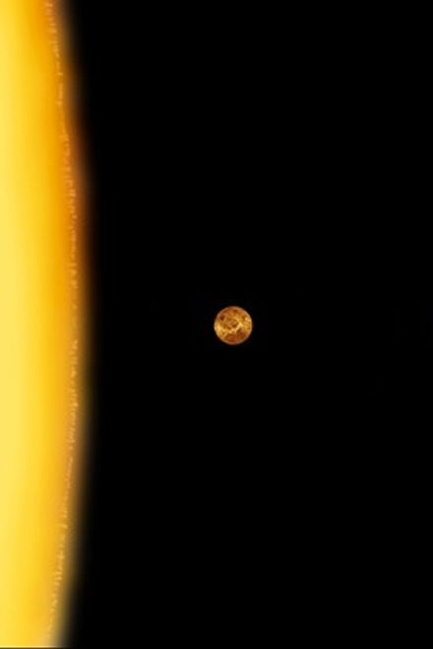

*A scale image of Venus relative to the disc of the Sun (Image: NASA)*

**Mars**

**Introduction**

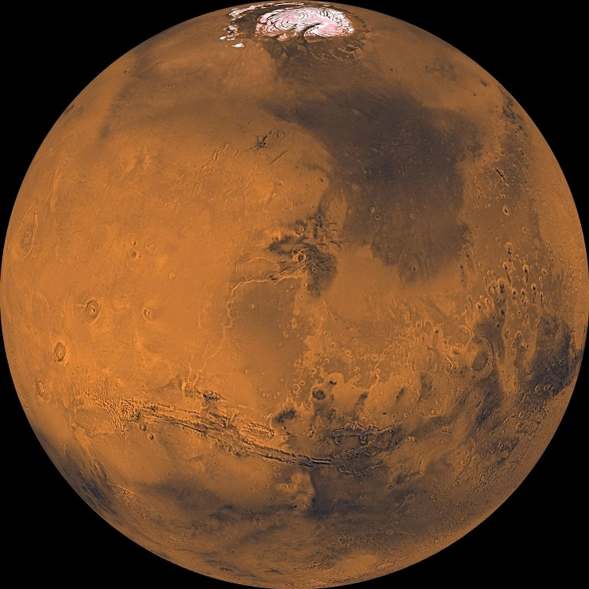Mars has long held a fascination with humans – maybe originally due to its colour, but in more recent times due to its mysterious features. It is host to the largest volcano and largest canyon in the solar system. Why is it such a small planet? What happened to the liquid water that must have once existed on its surface? Did life ever exist on Mars?

A diameter of 6,800 km makes Mars the second smallest planet in the solar system, and not a lot larger than Mercury (just under 5,000 km). Mars’s orbit is about 228 million km from the Sun, taking 687 Earth days to complete one orbit. One Martian day (known as a sol) is very similar to Earth’s at 24 hours 39 minutes.

Mars was known to the ancients, and named *Mars (Image: NASA)*  
after the Roman god of war, most likely as a   
result of its distinctive red colour, said to resemble fire and blood.

**Appearance and physical characteristics**

Mars’s red colour comes from the oxidised iron (rust) on its surface. Other prominent features include the seasonal polar caps, made mostly of frozen carbon dioxide (dry ice) with some water ice. On Earth water ice melts into liquid water and then when heated, turns to vapour (steam). On Mars, however, due to the low atmospheric pressure, when the ices on the polar caps melt, they sublimate directly from ice into vapour.

The Valles Marineris is the largest canyon in the solar system, stretching over 4,000 km long, up to 200 km wide and 7 km deep, and is clearly visible on the image above. This compares with the Grand Canyon in the United States which is over 400 km long, up to 30 km wide and 1.8 km deep.

Another “largest in the solar system” category is the volcano Olympus Mons, at nearly 22 km high, and covering an area of about 300,000 km2 (larger than the land area of the UK, 244,000 km2).

The extensive exploration of Mars has also revealed compelling visual evidence of what appears to be historic flowing liquid water.  
Mars no longer has a global 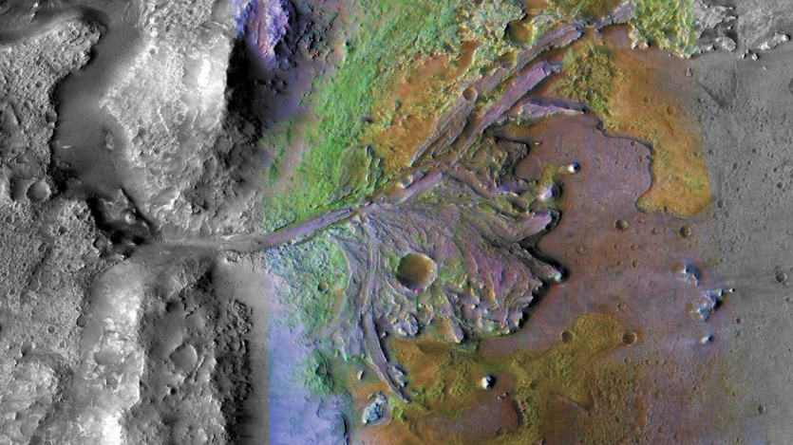magnetic field, and this, along with its weak gravity, has meant that it would have lost whatever atmosphere it had in its distant past and now only has a thin atmosphere comprising mostly of carbon dioxide. As a result, the liquid water that once flowed on the surface has now either gone underground or has evaporated into space as a result of solar radiation.  
This thin atmosphere also means *Visual evidence of liquid water flows on Mars (Image: NASA)*  
that the surface temperature on  
Mars varies significantly between   
day and night, with temperatures reaching a pleasant 20oC to as low as a bitter 150oC below zero.   
Another puzzle about Mars is why it is so small. The solar system was formed from a large disc of gas and dust surrounding the young Sun, and so the further from the Sun, the more material there was from which to form planets. Hence as a general rule, the planets get larger the further from the Sun they are. Therefore, in theory, Mars should have been at least a similar size to the Earth, if not larger. Current theories put this down to the jockeying for positions that the early planets undertook until they settled into their current orbits. In this case it is thought that Jupiter migrated inwards towards the Sun, dispersing much of the planetary building material there and thus starving the growing Mars. One can only speculate what might have been if Mars was much larger and therefore was able to retain its atmosphere and water…could life have flourished (and still be) there?

**Moons**

Mars has two very small irregularly shaped moons in orbit - Phobos (27 km by 18km) and Deimos (15 km by 11 km). It is thought that these could be captured asteroids.

**Exploration**

This potential for past life on Mars has in part fuelled our attraction to Mars, as it is, having had the most spacecraft visit it within the solar system, with over 50 craft launched since 1960 and including at least six robotic rovers. However Mars is also notoriously difficult to land on as a result of the very thin atmosphere and the time delay (at least 3 minutes one way) in communications meaning landing procedures have to be fully autonomous. Most of the early attempts failed at launch, in transit, or attempting to land. However a number of innovative landing methods have since been developed, including a sky crane that hovers above the ground whilst lowering the landing craft down on a cable, or surrounding the craft in giant airbags to cushion the final descent. As with Venus, the USSR led the early charge to visit Mars and the first (partially) successful lander was the USSR’s Mars 3 lander in 1971, however that failed less than 2 minutes after landing. The first fully successful lander was NASA’s Viking 1 in 1976.

**Key Data:**

Mass: 0.1 Earth masses

Orbital distance from the Sun: 228 million kilometres

Orbital Period (Martian year): 687 Earth days

Axial rotation (Martian day): 1.03 Earth days

Mean diameter: 6,800 kilometres (0.53 of the Earth’s diameter)

Maximum surface temperature: 20oC

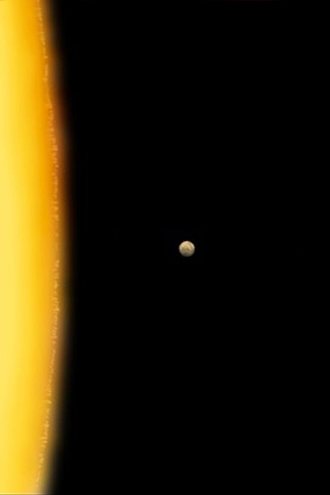

*A scale image of Mars relative to the disc of the Sun (Image: NASA)*